Cattle Breed Chart –

Economically Important Breeds

of Cattle

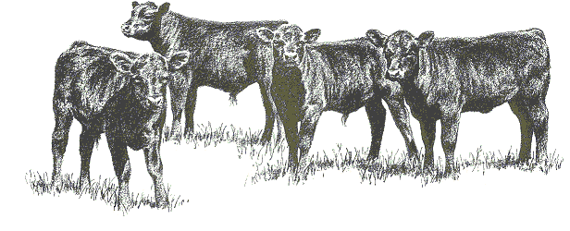

Introduction to Animal Science
Name:____________________________

Date: _______________

Complete the following information for each breed. Access the Oklahoma State University Virtual Livestock Library (www.ansi.okstate.edu/breeds) to download your pictures of each breed & to find origin, color pattern, and introduction to the United States.

Angus
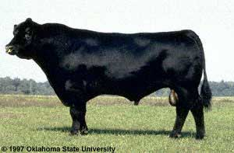

Distinguishing Characteristics:

Introduction to the U.S.:
Origin:

Color Pattern:

Hereford

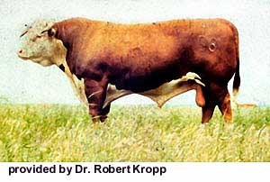

Color Pattern:
Origin:

Distinguishing Characteristics:

Introduction to the U.S.: .

Shorthorn
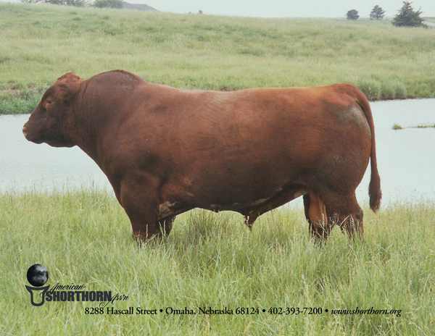

Insert picture here

Color Pattern:
Origin:

Distinguishing Characteristics:

Introduction to the U.S.:

Charolais
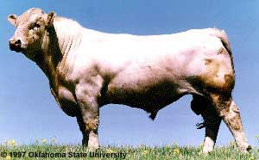

Color Pattern:
Origin:

Distinguishing Characteristics:

Introduction to the U.S.: .

Chianina

Limousin
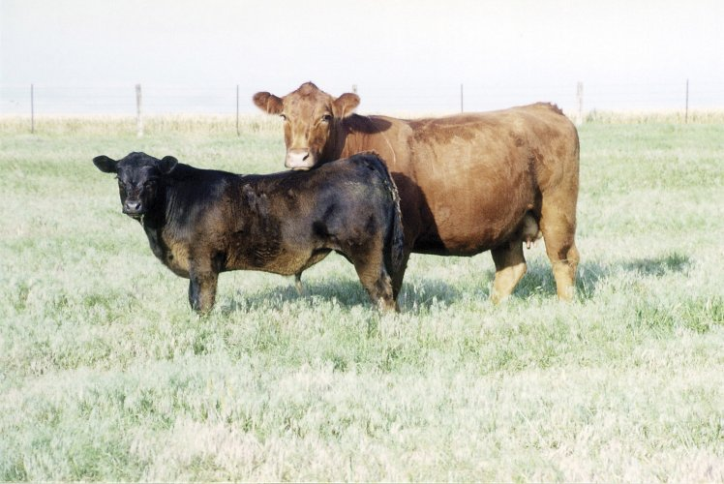

Insert picture here

Distinguishing Characteristics:

Introduction to the U.S.:
Color Pattern:
Origin:

Maine-Anjou
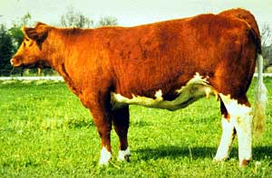

Insert picture here

Color Pattern:
Origin:

Distinguishing Characteristics:

Introduction to the U.S.:

Insert picture here

Red Angus
Color Pattern:
Origin:

Distinguishing Characteristics:

Introduction to the U.S.:

Simmental

Insert picture here

Color Pattern:
Distinguishing Characteristics:

Introduction to the U.S.:
Origin:

Distinguishing Characteristics:

Introduction to the U.S.:
Color Pattern:
Origin:

Brahman

Insert picture here

Beefmaster

Insert picture here

Color Pattern:
Origin:

Distinguishing Characteristics:

Introduction to the U.S.:

Insert picture here

Brangus
Color Pattern:
Origin:

Distinguishing Characteristics:

Introduction to the U.S.:

Santa Gertrudis

Insert picture here

Color Pattern:
Distinguishing Characteristics:

Introduction to the U.S.:
Origin:

Insert picture here

Holstein
Color Pattern:
Origin:

Distinguishing Characteristics:

Introduction to the U.S.:

Jersey

Insert picture here

Color Pattern:
Distinguishing Characteristics:

Introduction to the U.S.:
Origin:

Insert picture here

Ayrshire
Color Pattern:
Origin:

Distinguishing Characteristics:

Introduction to the U.S.:

Brown Swiss

Insert picture here

Color Pattern:
Distinguishing Characteristics:

Introduction to the U.S.:
Origin:

Insert picture here

Geurnsey
Color Pattern:
Origin:

Distinguishing Characteristics:

Introduction to the U.S.:

