Label the Digestive System

Terms:
pancreas; caecum; stomach; rectum; gall bladder
pyloric sphincter; small intestine; colon; liver; oesophagus; bile duct
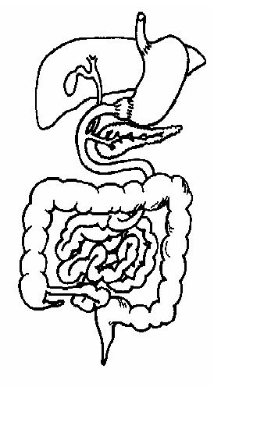

A. Rectum, B. Pancreas, C. Pharynx, D. Stomach, E. Gall bladder, F. Colon, G. Liver, H. Small intestine, I. Oesophagus, J. Pyloric sphincter, K. Rumen

Region/organ | Function
.......................... | Produces the enzymes to digest proteins, fats and carbohydrates in the small intestine. Also produces the hormone insulin
......................... | Micro-organisms digest cellulose in this modified part of the stomach
.......................... | Carries the food from the mouth to the stomach
......................... | Stores bile
.......................... | This muscle controls the passage of food out of the stomach
.......................... | Both food and air pass along this
.......................... | Indigestible matter held here before defecation
........................ | Produces bile
........................ | A bag made of muscle where food is held. Gastric juice and hydrochloric acid are added here.
........................ | Where food is mixed with bile and digestion of proteins, fats and carbohydrates takes place
........................... | Water and salt are absorbed here

