North Carolina Agriculture Project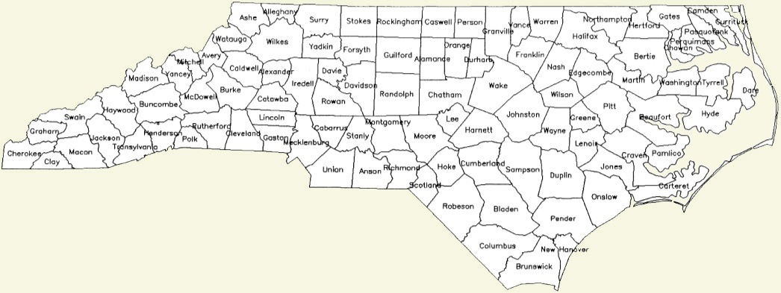
Go to http://www.ncagr.gov/stats/coest/Index.htm and answer the following:
Where are these agriculture commodities located at in North Carolina? Write down the top 3 counties next to each number and also which area they are located in. Ex: Corn; Onslow county, South East
Commodity | Top 3 Counties | Which part of the state?
- Burley Tobacco
- Corn for grain
- Cotton
- Hay
- Peanuts
- Wheat
- Broilers
- Milk cows
- Hogs
- Turkeys
- Sweet Potatoes
- Christmas Trees
- Blue Berries
- Apples
- Strawberries
- Grapes
- Sod
In the internet toolbar, type in http://www.ncagr.gov/stats/coest/Index.htm. Once there, answer the following questions.

- How many broilers were raised in Johnston County in 2011?

- How many bushels of soybeans did our county produce in 2011? What was our rank in NC?

- What are the three largest producing counties of sweet potatoes in NC? How does Johnston rank?

- How many tons of hay did our county production in 2012? How many acres were harvested? What was the top county’s name and tonnage recorded in 2012?

- How many acres and pounds of Flue-Cured Tobacco was harvested in Johnston county in 2012? Where do we rank?

- How many cows, chickens (broilers + layers), turkeys, and hogs does NC have in 2011? Which animal do we have the most of?

- What primary area of the state holds our turkey production?

- How has burley tobacco acreage changed in the last 10 years? How has flue cured tobacco acreage changed? (hint facts sheet)

- With the number of turkeys going down over the past 10 years, what has happened to the pounds produced?

- Has the Christmas tree production in NC increased or decreased since 1997? By how much?

