Cattle Unit Review
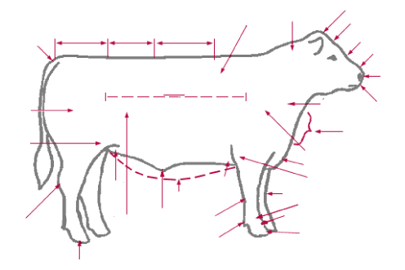

Word Bank: (1pt each)
Rump body loin crops rear flank fetlock last rib hock coffin underline hoof nose muzzle shoulder neck face foreflank poll quarter sheath/navel dewlap pastern knee stifle brisket dewclaw back tailhead forehead elbow shoulder vein cannon nostril

- Why is structural soundness of major importance in breeding heifer evaluation?

- List, describe and draw four structural defects.

- List the three components of volume in breeding heifers.

- Why is femininity an important factor to consider in breeding heifer evaluation?

- List three (3) traits of femininity.

- Define EPD and list the different traits it can predict.

- What is the most important view for evaluation of muscling in market steers?

True / False
Directions: Write true or false next to the statement
- Body builders have defined muscles; the same should be true for steers.

- A straight shoulder is desired in breeding heifers

- A correctly finished steer provides retail product without excessive trim.

- Volume is an indicator of the heifer’s fleshing ability.

- The deepest part of a heifer should be the chest floor.

- An ideal breeding heifer should display refinement through the muzzle.

Matching (2pts each)
- Bull ___ Older female that has given birth
- Steer ___ Non-castrated bovine
- Stag ___ Young female that has not given birth
- Heifer ___ Castrated young bovine
- Cow ___ Baby Bovine
- Calf ___ Castrated old bovine

Directions: Label and color in six different cattle below. Along with that be sure to write some distinguishing characteristics for each breed. (5pts each)
