/116 Name:_______________
Swine and Poultry Unit Test
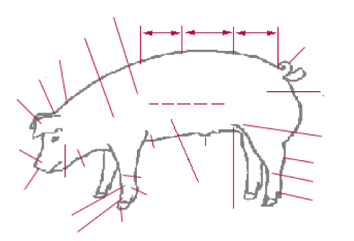

loin foreflank neck nostrils hock knee tail pastern stifle belly shoulder jowl dewclaw sheath ham coffin cannon side crops foreleg poll ear rump cheek rear flank fetlock back snout

/28
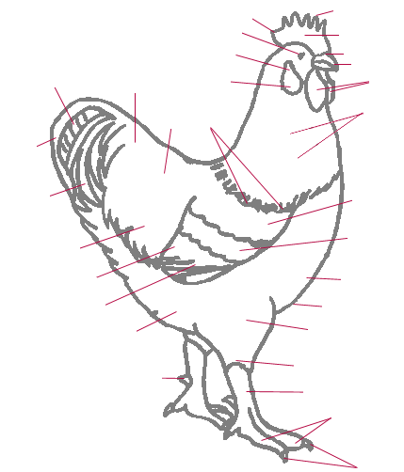
Blade wing bar single comb wattles hackle hock
toenails primaries wing bay cape saddle feathers
greater sickles thigh beak saddle lesser sickles
points of comb wing bow breast ear lobe
main tail feathers toes fluff nostril back
spur shank keel eye ear opening

/31

- Label the Following: Ham, Stifle, Loin, Ham-Loin Junction (4pts)

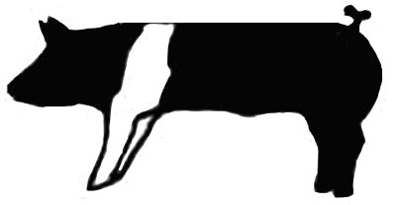

- What are the four lean cuts of meat in swine? (4pts)

- List and explain the terminology for swine and poultry. (9pts)

/17

Why is structural soundness of major importance in breeding gilt evaluation? (2pts)

- When reviewing the vulva on breeding gilts what are some things to look for? (3pts)

What management problem would be represented if the dewclaw were touching the surface when the gilt traveled? (2pts)

Why is a flat ribbed, and narrow-chested market hog undesirable? (2pts)

Name the three factors that indicate a gilt is feminine. (3pts)

/12

List and describe three breeds of swine and three breeds of poultry (12 pts)

How does ear lobe color correlate to egg color? (2pts)

True/False (2pts each)

A swollen hock is a direct result of no flexibility in the hock.

A sow is expected to produce 4-5 litters in confinement situations.

Structural soundness is the most important factor in evaluating market hogs

- An extremely deep bodied, muscular market hog is desired in modern pork production.

Inverted nipples are a non-heritable trait.

A groove down the center of the loin is an indicator of leanness.

An up-turned vulva is desired when selecting replacement gilts.

/28
Matching (2pts each)
A. Bull ___ Older female that has given birth
B. Steer ___ Non-castrated bovine
C. Stag ___ Young female that has not given birth
D. Heifer ___ Castrated young bovine
E. Cow ___ Baby Bovine
F. Calf ___ Castrated old bovine

